Maya Angelou Academy
6th Annual Power Unit
Speech Competition

November 3, 2015
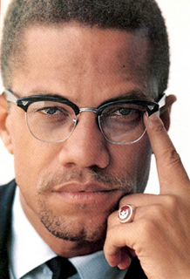
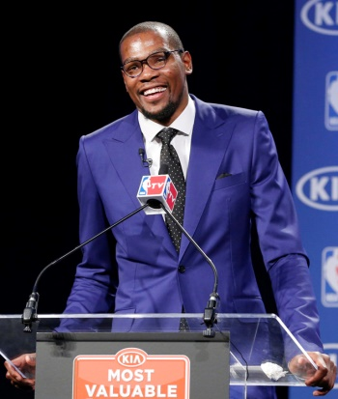
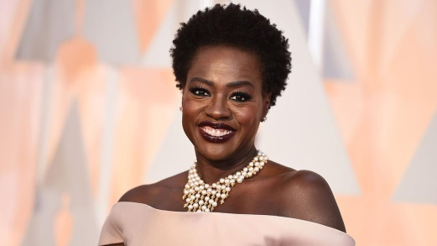
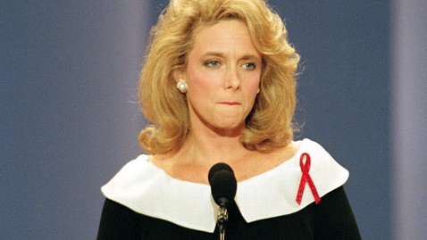
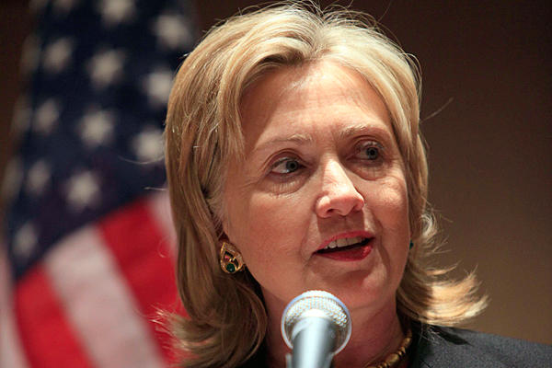
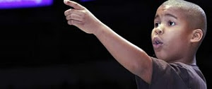
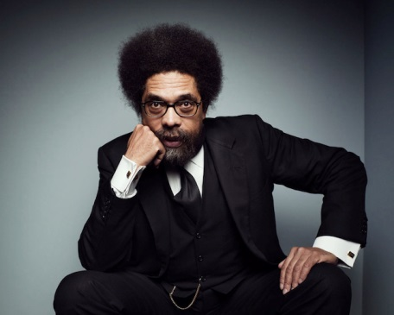
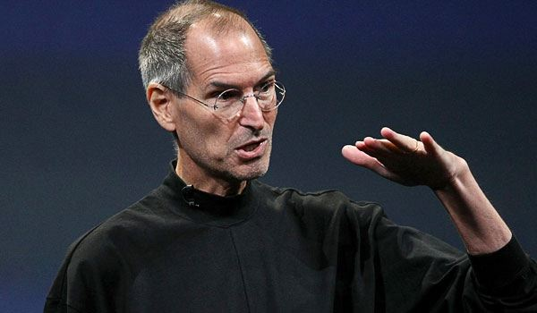
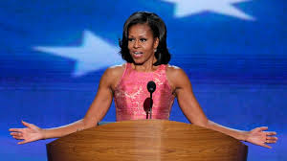
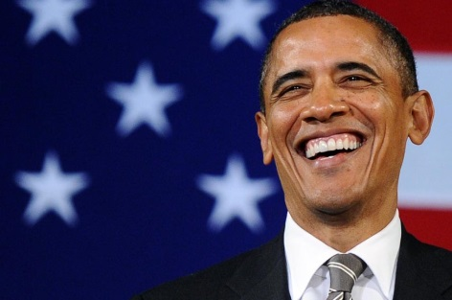
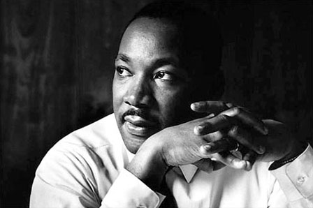
Clockwise from top: Dr. Martin King Jr, Kevin Durant, Malcolm X, Hilary Clinton, Dalton Sherman, Cornel West, Steve Jobs, Viola Davis, Mary Fisher, Michelle Obama, President Barack Obama. During the Power Unit, MAA scholars studied speeches from these individuals and other powerful speakers.

November 3, 2015

Welcome to Maya Angelou Academy’s 6th Annual Power Unit Speech Competition. During the Power Unit at Maya Angelou Academy all scholars wrote speeches on the subject of power. The scholars were able to select the target audience for their speeches and were given freedom to choose in what direction they wanted to take the subject of power. Some scholars chose to define power, some spoke of how power can be used and misused, some chose to reflect on the role a higher power plays in their lives, and some scholars chose to discuss the power of violence by the gun or even the power of their voices and communities. All scholars were required to utilize at least three of the following rhetorical devices: repetition, anecdote, hyperbole, allusion, hypophora, and analogy. The scholars also spent time studying the non-written aspects of a speech that make it more powerful, such as eye contact, hand gestures, presence, posture, and inflection.

Nine scholars were selected to compete in today’s competition by their teachers, staff, and peers. The selections were based on the content of the speeches, and also each scholar’s ability to effectively present his speech. Each scholar had the opportunity to present his speech to his residential unit at the end of the unit, and from there our finalists were selected.

The scholars have worked very hard on the writing and presenting of their original works. We thank you for giving them the opportunity to display their talents in front of an official audience!

The contestants for the 6th Annual Speech Competition at the Academy are:

Antwann (Genesis)
David (Imani)
Aaron (Transitions)
Patrick (Imani)
Dominique (Genesis)
Malik (Imani)
Daeyon (Reflections)
Nate (Genesis)
Malik (Reflections)

Antwann

The Power of Helping Others

Welcome students, DYRS staff, teachers, and guests. I’m Antwann, a scholar of Maya Angelou Academy. Have you ever felt powerful by helping others? Well today, I am going to tell you how powerful I felt by helping the seniors in my community. Booker T. Washington says, “Character is power.” I believe that my character shows niceness and caring for older people.
Let me tell you a short story about the power I had to help the people in my community. There was a couple named Mr. and Mrs. Graves who lived two doors from me. They were both in their 70s. I would always rake their yard and take out their trash. They would give me money to show their appreciation. My actions made me feel good and powerful. I learned to respect my elders, just like you should respect your mother. Helping others gives you power! Yes, helping others gives you power!
One day I was at the Safeway and I saw an older lady struggling with her grocery bags. I helped her carry her grocery bags to her car. She needed assistance because she was old. What would you do? You should always help. This shows how helping people can be powerful because it gets you respect. The lady told me I was a nice, young man with good things to come! That is the power of helping people.
I want everyone to know that I am a young man who cares about helping others. You can be powerful by helping others. Remember everything I said today! Take the power of helping with you today. Thank you!

David

Power

Power, what is power? Power is various different things. Power can be what it takes to stop smoking. Power can be that strength you have to supersede or to accomplish a goal. Power is determination, your mind is telling you quit but your heart is pushing for you to keep going. Power is when your back is against the wall, you have nowhere to run, nowhere to hide, so you push with all that you have left. What pushes “you” to keep going? What are “you” so passionate about that the doubters can’t pull you from? That is power!
We all look or think power is the muscles you have, the team with the biggest guns, or who has the most people on your team. No, power is also how you think, how you use your mind to succeed in short and long term goals. When you use the power you were born with you move mountains, create roads for those who cannot yet see the power given.
I challenge you to be more than a statistic. You have the power to amend life. I challenge you to not be recognized as the top drug dealer or the biggest car thief or robber. I challenge you to be recognized as that person who used the power of the mind to break records. Because I can tell you now that no child wants their parent to come to their school on career day and express to them how I’ve been in jail or I’m so thorough or that I don’t have a legal job because I’m too busy being that guy. I would want to come to my child’s school and say, “Oh, I’m a doctor, a firefighter, a construction worker, a mechanic, or even a crossing guard.” I want to give back to my community. Those are things that I want my child to remember and brag about. I want them to be proud of what I’ve come from and what I have become. We hold the power.

Aaron

Power

Good afternoon ladies and gentlemen. My name is Aaron. I’m here to talk to you about “power.” What is the meaning of power? To me, power is the ability to be in a position of authority. As stated by the Dali Lama, “The ultimate authority must always rest with the individual’s own reason and critical analysis.”
Look at President Obama for instance. He’s the President of the United States, which has the power of authority. His position gives him the power to change laws and make the country a better place. For example, President Obama changed the way health insurance is delivered and subsidized for millions of people. In the end, he followed his own mind, in spite of the naysayers. Do you believe Barrack Obama’s decision had a powerful impact? I believe it made an immense change and impact on today’s society.
Speaking of impact, there is someone in my life who has made an enormous difference for me. That is my Uncle Timothy.
There was this one time my uncle and I were having a disagreement and he told me, “With authority comes power, and with power comes authority.” I believe my uncle is a wise and strong-willed person. So when he has something to say I always open up and listen. I’m respecting my uncle’s input when I think and act for myself, honoring my own power and authority. So tell me, do you have what it takes to be in such a position? I have what it takes!! I believe you have what it takes also!!
I would like to thank you all who came out today to support me, and I strongly believe my words of wisdom will have an influence on everyone in the audience. With all that I’ve said, my purpose was to persuade you that to have power, you must be in a position of authority. And don’t forget, with authority comes power, and with power comes authority. I want everyone to have a blessed, peaceful, and powerful day.

Patrick

What is Power?

Good afternoon, my name is Patrick and I’m here today to define power and how it’s similar to freedom. So I ask, so I ask: What is power? Power is freedom. Power is Nelson Mandela. Power is Rosa Parks. Power is Maya Angelou.
See, Nelson Mandela had power. He was imprisoned for twenty-six years. He knew how it felt to be powerless and he never gave up. That’s what you call power. When he got out of prison he let his power be known by becoming the President of South Africa.
Rosa Parks, she had power. She had the power to stand up for her rights. She got locked up over a bus seat. When she was released she rebelled and had a lot of people behind her. They boycotted the buses until they felt they had the right to sit where they wanted. Rosa Parks would rather crawl then get out of a bus and have to give up her seat to another Caucasian. That’s what you call true power. The power to stand up for your rights.
You know who else had power? Maya Angelou had power. She got raped by her mother’s boyfriend and was traumatized. She stopped talking for several years. Then later in life she made a friend and guess who that was? His name was Martin Luther King Jr. They were very close. Then came Maya’s birthday the same day Dr. King was assassinated. Just think of the hurt you would feel if your best friend was murdered on your birthday. That caused Maya to shut down again and she stopped celebrating her birthday for years because of the hurt she felt every time she thought about Dr. King. Then she overcame her past and rose to be a beautiful and powerful woman who she always was. She started back talking and became the Poet Laureate for the first black President of the United States. That’s what you call power! She had the power to come out for her shell and rise to be one of the most powerful women in this world.
Thank you for listening to my speech and have a nice day. (bow and wave!)

Dominique

The Misuse of Power

Good afternoon to the people of New Beginnings. I am Dominique, a resident of New Beginnings. I am here to talk about the misuse of power. I believe power brings recognition, aka fame. Some people misuse power for fame, some to have a sense of control. Power can make you believe people are lesser, or under you. I believe a police officer abuses his power as an addiction abuses its addict.
I think people misuse power because they are angry and hateful. People feel that they have been wronged so they wrong others. When I was younger, me and my brother had a lot of confrontations. Needless to say, I didn’t win the majority of those confrontations. The way I see it is the fact that I grew up fighting made it much easier to see the world as it is. A place where people take advantage of the power they have, and only look out for themselves. If you want power, you have to earn it, because you can’t get anywhere without ambition.
I believe power has a heaven and a hell. A good side and a bad side. When you have power, your decision affects multiple people as if it’s a chain effect. I feel as though if your decision has a good effect then credit will be passed around if people think you aren’t good enough to make a good decision. If you make a bad decision people feel you’re good enough to be wrong. Envy also comes with power. People hate to see others in a successful position; some people will go to the extreme for power. People will kill for power or attention.
I think committing a crime is a misusage of power. When you rob a person you take their power. When someone else is helpless you feel powerful. Years of being powerless turn to a person that seeks for power. Seeking power or respect may get you a life in prison or hell. Adolph Hitler misused his power, but I believe many people have traits of the great Adolph. Some of those traits are hate, anger, and pain. How many people do you think really care about another’s well-being? I wouldn’t say a lot. Having power allows you to abuse your hate, and anger.
In conclusion, reaching the status of powerful may not be worth the risk. Maybe the stakes are too high. In the streets power brings death in a physical and mental sense. I believe life isn’t about power; it’s more about living. It’s about doing what you what to succeed in a world built for failure.
Malik

My Higher Power

Good afternoon family, staff, and residents. My name is Malik and today I’m here to speak to you about a higher power. Do you believe that there is a higher power? I do! Who do you believe is the higher power? I believe that the higher power is God.
For instance, I converted to Islam on September 24th, 2009. I remember when I first became curious about Islam, I was talking to my father on the phone and he told me he used to be Muslim. Later, I went over to my friend’s house because he was also curious about Islam and wanted to convert. He knew of a place to go and learn about this and we eventually did convert.
I converted to Islam because after studying a while, I started to believe that this could be something beneficial to my life. I also believed that it could be a fresh start mentally and could help me make a change. I learned that Islam involved discipline, peace, and humility, which I knew I needed in my life. After practicing Islam, I have become more humble and submissive for the love of “Allah.”
This was significant because even though I believe Allah is my higher power, I know that I have power within myself too. A wise man once said, “A man who wants to lead the orchestra must turn his back on the crowd.” To me, this means that if you want to progress and do something great; you must use the powers passed down to you by the higher power. You must use your abilities to excel to separate yourself, to change, to believe, and to succeed. In life, it’s good to turn your back to negativity because it will benefit you. What I’m trying to say is everyone has power. Whether it’s gained through a blessing or discovered through a hard time in life. You have the power of speech, wealth, determination, and self-control.
Power, I say again, power, so desired yet hard to obtain. Power is like a battery, you can use the positive side or the negative side, but at the end, it’s up to you. I say this because I believe that the higher power is positive, but it’s your choice and your choice alone to follow him.
To conclude, I truly do believe that there is a higher deity than just me, and you. I believe that the higher power created this world with power. Some of the powers that we all hold as a human race in this so powerful world are just examples of this! I believe in a higher power! I believe in his name “God.” I believe.

Daeyon

Power

BANG, BANG, BANG, you hear out your living room window. Then you take a peek, don’t see any police, no military people, no wild animals, so that means so hunters. What you do see is your neighbor running for their lives, because someone with an illegal gun decided to shoot someone. More than likely the person being shot at has an illegal gun also. But this time they’re too slow to pull it because they are down on the ground.
These people think that having that gun gives them power. The feeling you get squeezing that trigger. The feeling you get when the power of the gun makes your hand jerk. The feeling you get when you hear that POW, POW, BANG, BANG, sound.
Welcome ladies and gentlemen. I’m Daeyon and I’m here to speak to you about how power plays a role in the gun control debate.
After the recent shooting in Oregon, President Obama said, “That means there are more American families – moms – dads – children whose lives are changed forever. That means there is another community stunned with grief and communities across the country are forced to relive their own pain, and parents across the country who are scared because they know it might have been their families or their children.”
This needs to end!! We have the power to stop it. We can have and sell guns for the military, police, and people with a license for hunting. We can have it all. What we can’t have is harming others with our guns. That’s just hurting families. Is that what we’re about? Is that what we’re about, hurting each other and our families? Is it about what color we are? Is it about where we are from: hood, state, or country? Is it about what we wear?
We need this to end and we need to see that what is happening with guns right now is not right and it’s not fair. Thank you for listening to my speech. I hope you understand my message.

Nate

A Higher Power

Good morning everyone who is here today, my name is Nathan. Today I’m here to inform you about my higher power and how he affects my life. First and foremost, I am very thankful and grateful for my higher power guiding me through the good, bad, easy, and hard times. When I pray and ask for forgiveness times become better and make me feel consistent with being able to hold my composure. I know my higher power will forgive me and gives wisdom to all men liberally but as a result of that, I don’t have inconsistent downfalls.
In Matthews Chapter 7, Verse 7 of the Bible, it says, “Ask, seek, knock, for those who ask, receives, those who seek, will find, and the door will be open to those who knock.” That’s an important part of the Bible because it’s telling you how to get things and be guided to the road of righteousness, and prosperity.
What is the point of a higher power? Is a higher power useful or not? The point of a higher power is to have someone or something more superior than you to guide you, ease your mind, and help you keep faith and want to be better for yourself. Yes, a higher power is useful in so many words and ways.
So, I challenge you today, when you are having difficult times and obstacles come, turn to your higher power and ask him to ease your mind and fulfill it with wisdom and insight.

Malik

The Power of Power

Good afternoon teachers, staff, and residents of New Beginnings. My name is Malik and today I’m here to speak to you about THE POWER of power. What I want you all to do is ask the person sitting beside you, WHAT is power? Is power being RICH? Is power SHOOTING or HURTING another person? Is power being in CONTROL all the time? Let’s find out.
To many people it seems that power is achieved through VIOLENCE. The definition of power in the Webster’s Dictionary is, “the ability to do or act; capability of doing or accomplishing something.” A wise man once said, “KNOWLEDGE will give you POWER, but CHARACTER, RESPECT.” Bruce Lee was a wise, peaceful leader. He was the greatest martial artist of all time, but he wasn’t VIOLENT.
Once every million years Earth breeds a non-violent leader. I am a powerful leader because of my knowledge, not because I can fight or kill someone. In third world countries such as Africa, people are fighting and killing each other over education. My advice to you all before I wrap this up, is that if you WANT to be a POWERFUL LEADER, POWER is the door and EDUCATION is the key, so enhance your education.
Before I go, I want to tell you all a story. I’ve been to Residential Treatment Centers all across the United States. In EVERY residential I’ve been to, I seem to have a titanic influence on a majority of the residents and staff. Can you believe that in every residential I’ve been to; staff told me the same thing? You ARE a LEADER, you ARE a LEADER, you ARE a LEADER, is what I’ve been told for years. I say that to say this: Leaders are transformed, not born. Thank you for your time.

The following writings are original speeches written by scholars at the Maya Angelou Academy.

“Your voice is the most powerful power we all have, so use it.”
–Angela Davis

