REQUEST FOR PROPOSAL
FOR
CURRICULUM & INSTRUCTIONAL SUPPORT
AT
MAYA ANGELOU PUBLIC CHARTER SCHOOL

PROPOSALS MUST BE UPLOADED TO:
https://app.smartsheet.com/b/form/6252925bdba94255be92aadb1d556ef8

NO LATER THAN 12 NOON JULY 5, 2018

MAYA ANGELOU PUBLIC CHARTER SCHOOL

REQUEST FOR PROPOSALS

Curriculum and Instruction Support

- Overview of Facility
- Maya Angelou Public Charter School (MAPCS) is located at 5600 East Capitol Street NE, Washington DC 20019. Our mission is to create learning communities in lower income urban areas where all students, particularly those who have not succeeded in traditional schools, can succeed academically and socially.
- Intent and Definitions
  - The term “MAPCS” means Maya Angelou Public Charter School.
  - The term “contractor” or “bidder” means the responsible bidder. The term “successful contractor” or “successful bidder” refers to the bidder awarded the contract.
  - The intent of this solicitation is to procure a contract for professional development and instructional coaching for MAPCS staff that is consistent with MAPCS’ “Beyond the Diploma” philosophy and common core standards.
  - “Beyond the Diploma” means that MAPCS strives to prepare students for life beyond the diploma, setting each student on a pathway to college or career through personalized learning, a standards-based curriculum, and social-emotional learning support. (See addendum 1 for details.)
  - PD means professional development and instructional support for staff at MAPCS
- Goals of this RFP
  - Support the development of a cohesive framework for unified approach that incorporates best pedagogical practices and blended learning;
  - Implement a strategic network vision of the “Beyond the Diploma”;
  - Realize high-quality College & Career Readiness curriculum for ELA/literacy and mathematics
  - Coach MAPCS staff so that they can meet the unique needs of each student. Staff must not only be able to meet each student “where he or she is” but also engage each student to help realize his or her potential.
- Contractor Requirements
  - Have a proven track record of working with similar entities (e.g., urban schools that cater to at-promise youth) to develop customized PD and curriculum support to achieve strategic vision;
  - Provide an adaptive and high-impact PD for MAPCS teachers and leaders;
  - Employ materials are current, engaging, and relevant to the “Beyond the Diploma” vision and common core standards;
  - Consider needs of students at different schools and different pathways
- Scope of Work
  - Work with MAPCS administration to develop a framework that:
    - Exceeds the Common Core standards
    - Achieves the five pillars of the “Beyond the Diploma” vision (Addendum 1)
    - Incorporates a blended-learning environment;
    - Employs a data-driven approach;
    - Connects curriculum to credit accumulation and flexibility (credit recovery)
    - Is customizable to ensure that instructors have the resources necessary to meet each student’s unique needs;
    - Incorporates intervention strategies;
    - Sets instructional expectations for teachers based on the curriculum, including planning, documentation of student progress, and guides to instructional blocks;
    - Establishes effective Professional Learning Communities (PLCs) of instructors;
    - Develops the coaching expertise of MAPCS administration and school leaders;
    - Implements pedagogical best practices through inquiry-based cycles of PD.
  - Work with MAPCS administration to provide ongoing PD that enhances execution of strategic vision and continually enhances instructors’ abilities;
  - Devise a successful PD program to ensure that the MAPCS team adjusts and adapts curriculum resources so that students thrive academically;
  - PD and support should include strategies for the following:
    - Exceeding common core standards in classrooms with at-promise youth;
    - Implementing blended-learning environments;
    - Meeting students where they are currently at;
    - Engaging students;
    - Teaching in non-traditional settings;
    - Employing an inquiry-based approaches;
    - Connecting curriculum accumulation flexibly (credit recovery);
    - Incorporating different areas of content (interdisciplinary literacy);
    - Increasing student writing opportunities;
    - Engaging students in their pursuit of academic excellence.
  - PD for ELA/Literacy should cover the following:
    - Designing standards-aligned, text-dependent questions and tasks to engage students;
    - Creating a classroom culture that encourages participation of all students in activities and discussions;
    - Scaffolding for a deeper understanding of text by strategically sequencing questions and identifying keys for struggling students;
    - Devising research-based best practices around vocabulary instruction;
    - Implementing strategies to facilitate student-centered conversations about text to enhance reading, communication, and listening skills;
    - Developing school and classroom culture to Implementing strategies to allow effective learning of students at different levels;
    - Designing tasks in a manner that allows students to engage deeply with rich content.

  - PD for Mathematics should cover the following:
    - Determining the best approaches to instruction based on rigor of standards and the diverse needs of the students;
    - Using manipulatives to make all content engaging and accessible to students;
    - Employing strategies to relate content to actual practical real-world situations;
    - Implementing techniques to develop classroom culture where students explain mathematical reasoning in their own words while others listen;
    - Devising innovative systems to have students share solution pathways and mathematical representations.

- Evaluation Criteria
  - The following criteria will be used to evaluate each proposal:
    - Cost
    - Function
    - Fit with MAPCS’ Beyond the Diploma strategic vision
    - Experience
    - Quality
    - References
    - Company’s mission/ involvement with DC community/CBE
  - MAPCS will evaluate each proposal. Cost will not be the sole factor when awarding the contract. MAPCS reserves the right to reject any or all proposals.
  - MAPCS reserves the right to negotiate further with the successful bidder. The content of the RFP and the successful contractor’s proposal will become integral parts of the contract but may be modified by the provisions of the contract.
  - As MAPCS is committed to serving the DC community, consideration will be given to businesses based in Washington DC that employ district residents.
- Contractor Expectations
  - All inquiries regarding technical specifications and questions can be emailed to Dr. Clarisse Mendoza at cmendoza@seeforever.org.
  - Allowances will not be after contractor’s proposal is received due to oversight, omission, error, or mistake of the contractor.
- Eligibility
a. To be eligible for award, the contractor shall:
    - Be licensed to do business in the District of Columbia. The amount of the bid shall not exceed the license limit;
    - Capable of providing qualified staff who can pass a background check;
    - Have sufficient liability insurance;
    - Describe general relevant experiences with projects similar to the one described in this RFP;
    - Include three references.

- Bid Details/Required Submittals
- The bid must include:
- Detailed proposal to realize the goals of this RFP and PD consistent with the “Beyond the Diploma” vision (e.g., calendar of proposed PD session, hours required to develop a framework, etc.) and common core standards;
- Details of the proposed approaches to help instructors in areas of ELA/Literacy and Mathematics as well as achieve blended learning;
- Detailed bid that breaks out services by line item (e.g., cost per PD, planning sessions with admin). The bid should specify if this is exclusive price for all services. If there are exclusions, the exclusions should be clearly stated along with a proposed rate to add such exclusions. Note that additional administrative time, travel time to MAPCS, etc. are not billable expenses;
- Plan to communicate and work with MAPCS administration to development of a robust, sustainable, and targeted ongoing PD program;
- Information about use of intended materials employed in PD sessions;
- Whether your company is a small business, based in DC, or a Certified Business Enterprise;
- Three references;
- Proof of liability insurance.
- Proposal must be signed by an officer of the contractor who is legally authorized agent to enter into a contract.
- MAPCS reserves the right to consider proposals with minor variances with respect any specific requirements specified herein but judged to meet the intent of this specification. Such waivers shall not modify any remaining RFP requirements or release contractor from full compliance with the RFP specifications if awarded the contract.
- Bid Proposal Acceptance and Information
  - All bid proposals will be accepted until 12:00 PM on July 5, 2018.
  - Interested vendors will respond to the advertised Notice of RFP via upload to
https://app.smartsheet.com/b/form/6252925bdba94255be92aadb1d556ef8
RFP details can be found at www.seeforever.org/requestforproposals.
  - Any proposal received after 12:01 PM on July 5, 2018 is deemed non-responsive and will not be considered. Proposals will not be accepted by oral communications, telephone, electronic mail, telegraphic transmission, or fax.
  - All costs attributable to the preparation of a proposal or any presentation required to supplement or clarify the proposal are borne by the contractor.
  - MAPCS will rank the proposals in terms of meeting the requirements of this RFP. Additional information may be sought from contractor during the evaluation period.
  - All proposals will remain valid for a minimal period of 45 days subsequent to the RFP closing date.
- Award
  - The successful contractor shall enter into a contract for the performance of the work proposed and the contract shall incorporate all applicable provisions of this RFP.
  - MAPCS reserves the right, in its sole discretion, to award the contract to another contractor if contract negotiations do not appear successful.
- Payment Arrangements
  - Unless the contract stipulates otherwise, payment will be made as follows:
    - Time and materials work orders will be invoiced by Contractor. MAPCS will make payment within thirty (30) days of receiving the invoice.
    - If MAPCS makes the payment within fourteen (14) days from receipt of the invoice, a three percent (3%) credit of the invoiced amount will be credited to the next invoice. There is no credit or penalty if this payment is not received in this window.
14. Bid
a. In accordance with the provisions of the proposal, the undersigned hereby proposes to furnish all labor and materials for tutoring services. In addition, the undersigned hereby proposes to provide tutoring services at Maya Angelou Public Charter School located at 5600 East Capitol Street NE, Washington DC 20019.

SIGNED: __________________________________________

TITLE: FULL NAME: (Please Print) __________________________________________

COMPANY NAME: __________________________________________

COMPANY ADDRESS: __________________________________________

PHONE NUMBER: __________________________________________

b. Please attach your detailed bid. It must include proof of licensing, liability insurance, workman compensation for contractor’s employees, warranties, etc.

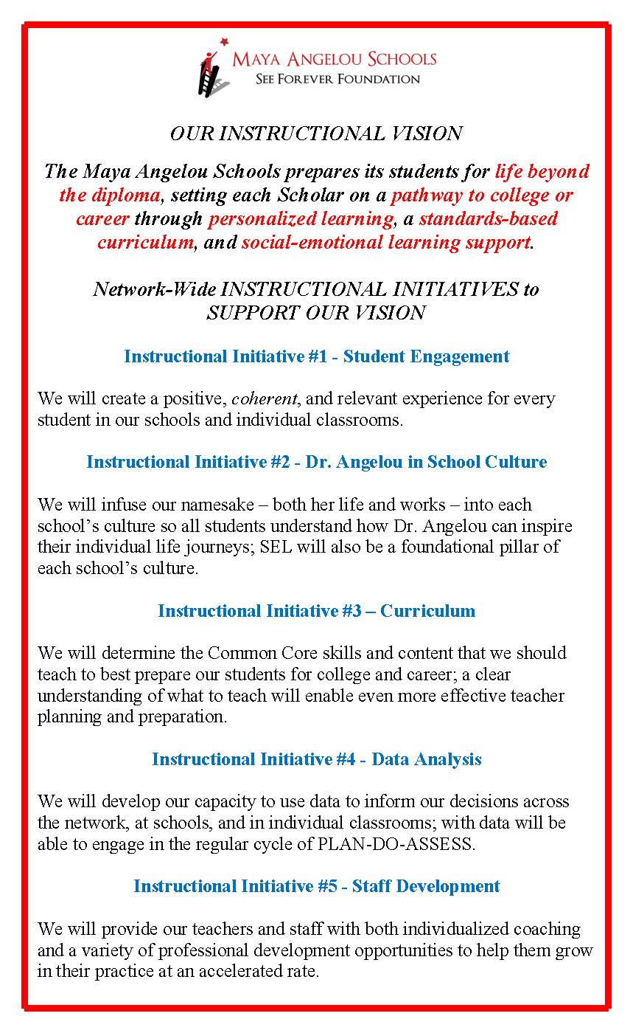
Addendum 1: Beyond the Diploma

